Assignment -1

1.used iTerm

2.

3.

4.

Identity :

5.

6.

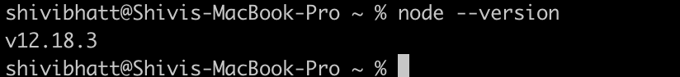

7.

.gitignore file screen shot:

README.md file screen shot

9.

Github classroom :

10. Git config added username, name and email:

11. push repository

